Name:

Block: Date:

**Math 10 – Trigonometry Homework #1**

|  |
| --- |
| **Formula 🡪 Substitute 🡪 Steps to Solve 🡪 Answer** |

|  |
| --- |
| a2 + b2 = c2 a2 = c2 – b2 b2 = c2 – a2 |

1. Show your **intermediate steps** to determine the length of the missing side:

1. 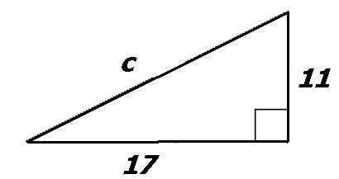
2. 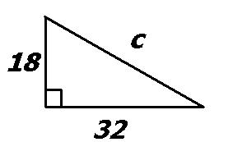
3. 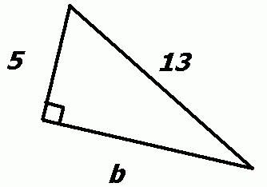
4. 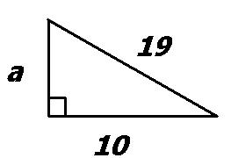
5. 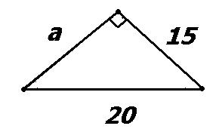

|  |
| --- |
| **Formula 🡪 Substitute 🡪 Steps to Solve 🡪 Answer** |

|  |
| --- |
| a2 + b2 = c2 a2 = c2 – b2 b2 = c2 – a2 |

|  |
| --- |
| **Use the information below to help answer the following question** |

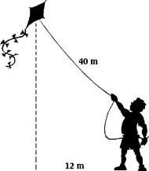

Cai is flying a kite on a **40 m** string.

He is standing **12 m** from his backpack.

1. How high **directly above** the backpack is the kite?

|  |
| --- |
| **Use the information below to help answer the following question** |

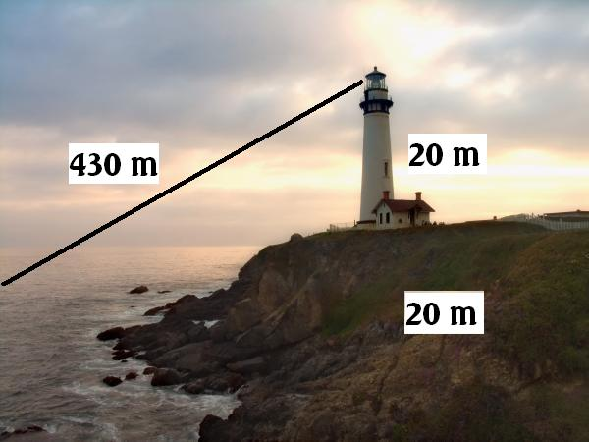Liam lives in a lighthouse in Ladner.

The lighthouse is **20 m** in height and sits upon a **20 m** cliff.

Liam spots a boat **430 m** away along the diagonal.

1. How far is the boat **from the rocks** at the bottom of the cliff?

|  |
| --- |
| **Use the information below to help answer the following question** |

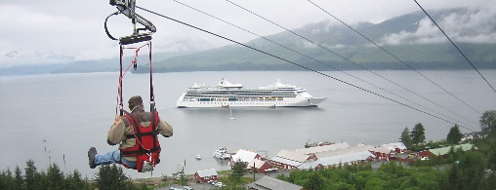

Maddie is riding the world’s longest zipline in Hoonah, AK.

The zipline itself is **5330 ft** in length and has a **1330 ft** change in elevation.

1. What is the **horizontal** change in distance?