Name:

Block: Date:

# **Math 8 -- Exponents Homework #4**

|  |
| --- |
| Show your**intermediate steps** to solve each question. |

|  |
| --- |
| Formula 🡪 Substitute 🡪 Steps to Solve 🡪 Answer (units) |

|  |
| --- |
| a2 + b2 = c2 a2 = c2 – b2 b2 = c2 – a2 |

1. Determine the **length** of the missing side in the following right triangles:

|  |  |
| --- | --- |
| pythagproblems1A |  |
| pythag_thm1A.JPG |  |
| pythagproblems1AAA |  |

|  |
| --- |
| Formula 🡪 Substitute 🡪 Steps to Solve 🡪 Answer (units) |

|  |
| --- |
| a2 + b2 = c2 a2 = c2 – b2 b2 = c2 – a2 |

1. Stanley was building a wall and took the following measurements. Are his corners true (squared)?

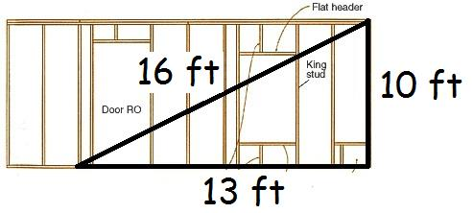

1. A building casts a shadow that is **25 m** long. Ali determined that it is **65 m** from the end of the shadow to the top of the building.

**How** **tall** is the building?

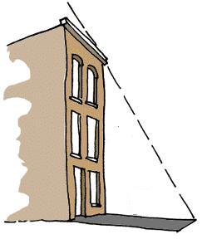

1. Ashia stood at the top of a **52 m** building that is leaning over. She dropped a cannonball which fell **48 m** straight down to the ground. **How far** from the **base** of the building did the cannonball land?

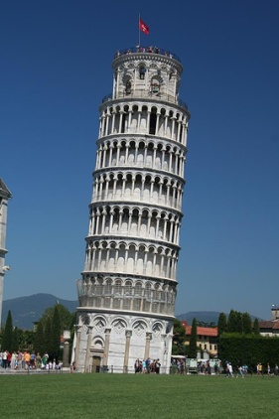

1. Mataya has a square swimming pool with an area of **400 m2** and is completely surrounded on each side by a **2 m** sidewalk.

Determine the **length of fence** that would be needed to surround the **outside edge** of the sidewalk.

