Name:

Block: Date:

**Math 10 – Trigonometry Homework #5**

|  |
| --- |
| **Formula 🡪 Substitute 🡪 Steps to Solve 🡪 Answer (units)** |

|  |
| --- |
| sine θ = $\frac{opposite}{hypotenuse}$ cosine θ = $\frac{adjacent}{hypotenuse}$ tangent θ = |

|  |
| --- |
| **Use the information below to help answer the following question** |

From the 10th floor of the Royal Tower (**30 m** high) Jedd looks down West Georgia Street to see Keagan and Gillian in the Sun Run.

He can see Keagan with an **angle of depression** of **18°** and Gillian with an **angle of depression** of **30°**.

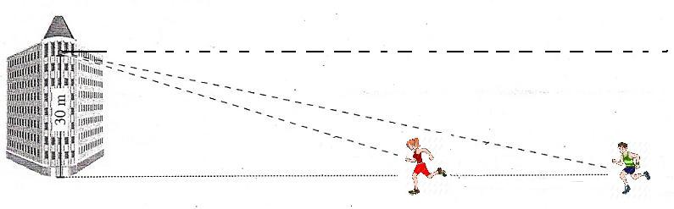

1. How **far apart** are Gillian and Keagan from each other?

|  |
| --- |
| **Formula 🡪 Substitute 🡪 Steps to Solve 🡪 Answer (units)** |

|  |
| --- |
| sine θ = $\frac{opposite}{hypotenuse}$ cosine θ = $\frac{adjacent}{hypotenuse}$ tangent θ = |

|  |
| --- |
| **Use the information below to help answer the following question** |

Emma and Austin are standing across a river from a radio tower that is **50 m** in height.

Emma sights the top of the tower with an **angle of elevation** of **22°**.

An angle of **36°** is formed along the surface of the river to a point directly across the river from Austin.

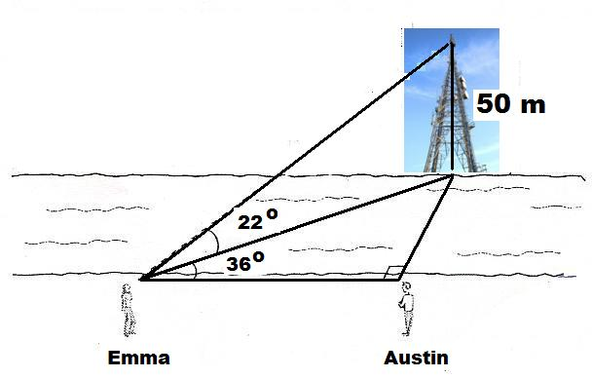

1. How **wide** is the river AND how **far** from Austin is Emma standing?