Name:

Block: Date:

**Math 10 – Trigonometry Homework #4**

|  |
| --- |
| **Formula 🡪 Substitute 🡪 Steps to Solve 🡪 Answer (units)** |

|  |
| --- |
| sine θ = $\frac{opposite}{hypotenuse}$ cosine θ = $\frac{adjacent}{hypotenuse}$ tangent θ = $\frac{opposite}{adjacent}$ |

1. In **∆XRY**, angle **R = 90°**, side **XY = 17 cm** and side **XR = 15 cm**. Determine the measure of **angle Y**.

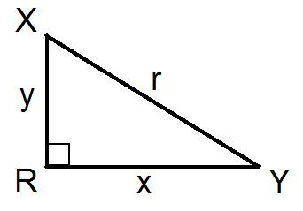

1. In **ΔMNP**, angle **P = 90°**, side **PN = 28 cm** and **side MN = 35 cm**. Determine the measure of **angle N**.

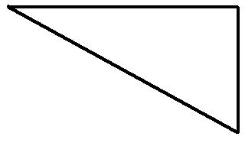

1. In **ΔDEF**, angle **E = 90°**, side **DE = 6 m** and side **EF = 10 m**. Determine the measure of **angle D** .

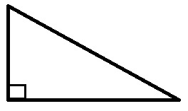

1. In **ΔRXY**, angle **R = 90°**, side **XR = 15 cm** and side **RY = 200 cm**. Determine the measure of **angle X** :



|  |
| --- |
| **Formula 🡪 Substitute 🡪 Steps to Solve 🡪 Answer (units)** |

|  |
| --- |
| sine θ = $\frac{opposite}{hypotenuse}$ cosine θ = $\frac{adjacent}{hypotenuse}$ tangent θ = $\frac{opposite}{adjacent}$ |

1. On a clear day, Avneet could see Anoop in Rochester, NY (**157 km** across Lake Ontario) from the Edge Walk of the CN Tower in Toronto. If the Edge Walk is **356 m** in height, what was the **angle of depression** formed?

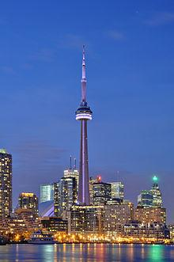

1. WorkSafe BC recommends that you follow the 4–to–1 ratio for ladder safety. [For every 4 m in height up the wall, the base of the ladder must be set 1 m ] from the base of the wall. What is the **angle of elevation** formed?

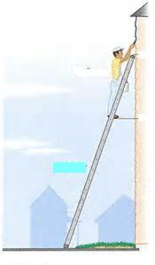

1. Angus rode his bike **25 km** along the Kettle Valley Railway. If he had a **vertical** lift of **500 m**, what was the **angle of elevation** of the path?

