Name:

Block: Date:

**Math 10 – Trigonometry Homework #3**

|  |
| --- |
| **Formula 🡪 Substitute 🡪 Steps to Solve 🡪 Answer (units)** |

|  |
| --- |
| sine θ = $\frac{opposite}{hypotenuse}$ cosine θ = $\frac{adjacent}{hypotenuse}$ tangent θ = $\frac{opposite}{adjacent}$ |

1. In **ΔXRY**, angle **R = 90°** and angle **Y = 26°**. If **side RY = 30 cm**, determine the length of **side RX** .

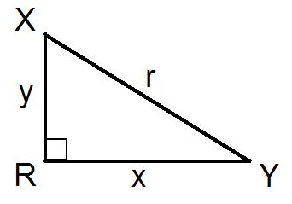

1. In **ΔXRY**, angle **R = 90°** and angle **X = 51°**. If **side XY = 14 m**, determine the length of **side XR** .



1. In **ΔXRY**, angle **R = 90°** and angle **Y = 27°**. If **side XY = 60 km**, determine the length of **side RX** .



1. In **ΔXRY**, angle **R = 90°** and angle **X = 28°**. If **side RY = 50 m**, determine the length of **side RX** .



|  |
| --- |
| **Formula 🡪 Substitute 🡪 Steps to Solve 🡪 Answer (units)** |

|  |
| --- |
| sine θ = $\frac{opposite}{hypotenuse}$ cosine θ = $\frac{adjacent}{hypotenuse}$ tangent θ = $\frac{opposite}{adjacent}$ |

1. Emma is standing **25 m** from a tree and sights the top of the tree with an **angle of elevation** of **56°**. Calculate the **height** of the tree.



1. Zelda’s Zipline has a length of **750 m**. If the zipline has a maximum angle of elevation of **3°**, what is its **vertical drop**?

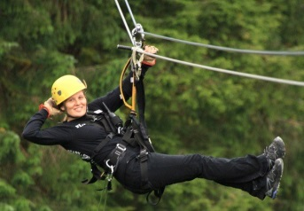

1. In the Nelson Knee Knocker, runners race **1.6 km** up a hill with an **angle of elevation** of **17°**. What is the **elevation change** of the road ?

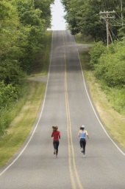

1. A wheelchair ramp is being constructed with a **5°** **angle of elevation**. What length of **ramp** needed to create a **vertical** lift of **1 metre**?

