Name:

Block: Date:

**Math 10 – Trigonometry Homework #2**

|  |
| --- |
| sine θ = $\frac{opposite}{hypotenuse}$ cosine θ = $\frac{adjacent}{hypotenuse}$ tangent θ = $\frac{opposite}{adjacent}$ |

1. Which **equation** would be used to find **sin X** ?

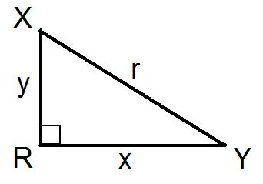

1. **Explain** why **sin X** and **cos Y** produce the same results, no matter what sized right triangle is used :



1. Explain why **sin X = $\frac{13}{12}$**  produces an error message on a calculator :

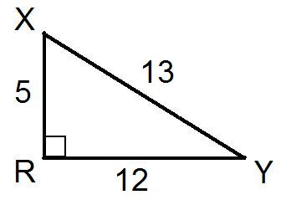

1. Label the dimensions of the triangle below so that **sin X = 0.500** :



|  |
| --- |
| sine θ = $\frac{opposite}{hypotenuse}$ cosine θ = $\frac{adjacent}{hypotenuse}$ tangent θ = $\frac{opposite}{adjacent}$ |

1. Determine the **ratio** of **cos X** : (leave the ratio in radical format)

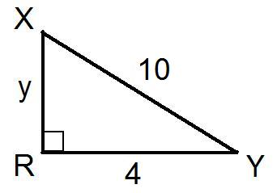

1. Determine the **ratio** of **tan Y** :

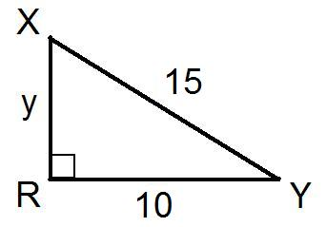

1. Determine the **ratio** of **cos B** :

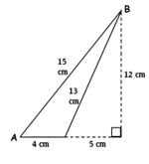

|  |
| --- |
| **Use the picture below to help answer the next question** |

A **7%** grade indicates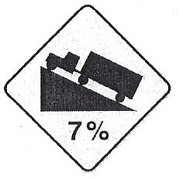 a rise of 7 metres for a horizontal change of 100 m

Assume **Angle Y** is the **angle of elevation** of the road.

1. Determine the **ratio** of **cos Y**