|  |
| --- |
| **Math 10 – Unit Assignment (Trigonometry)** |

|  |
| --- |
| Consider using a **diagram** to help solve each question. |

|  |
| --- |
| **Formula 🡪 Substitute 🡪 Steps to Solve 🡪 Answer (Units)** |

1. Cai was able to use a triangle to **explain** why **sin 32° = cos 58°**
2. Draw and label a triangle to help **explain** why cos θ = $\frac{20}{13}$ is **NOT** possible.
3. In an **isosceles** **right triangle** with equal sides of **15 cm**, Harleen used **trigonometry** to explain the measure of the two interior angles.
4. Lucia and Maria travelled on a road that increased **8 m** in altitude for every **100 m** of horizontal distance. Calculate the **angle of inclination** of the road, to the nearest degree
5. Anna’s apple tree is supported by a guy wire that is anchored to the ground **7 m** from the base of the tree. The angle between the wire and the level ground is **60°**. How **far up** the tree does the wire reach, to the nearest tenth of a metre?
6. Sosuke leans a **7 m** ladder against his house. The base of the ladder is **2 m** from the house. What is the **angle of inclination** of the ladder to the nearest degree?
7. Phillip stood atop a ski jump that is **116 m** long. It has a vertical rise of **54 m**. What is the jump’s **angle of inclination** to the nearest degree?
8. A tree is supported by a guy wire. The wire is anchored to the ground **7 m** from the base of the tree. The angle of inclination of the wire is **65°**. Help Aaron calculate the **length** of the wire to the nearest tenth of a metre.
9. The angle of inclination of a road is **6°**. Determine the **rise** of the road, to the nearest metre, for every **50 m** that Haydn travelled along the road.
10. Jedd’s Jungle Jumps has a zip line with an **angle of depression** of **10°**. If the change in elevation is **25 m**, what is the **length** of the zip line?

|  |
| --- |
| **Formula 🡪 Substitute 🡪 Steps to Solve 🡪 Answer (Units)** |

1. Celeste drew ∆ ABC. If angle **C = 90º**, side **AB** is **40 cm** and side **BC** is **12** cm, what is the measure of **angle A**?
2. Nikki drew ∆ ABC. If angle **C = 90º**, angle **A** = **13º** and side **BC** is **19** **cm**, what is the **length** of **side AB**?

|  |
| --- |
| **The following questions are worth 2 points each** |

1. From the roof of Keyessa’s Kondos, the **angle of elevation** of the top of Tyra’s Tower is **37°**. The **angle of depression** to the base of the Tower is **28°**. The buildings are **21 m** apart. Determine the **total height** of Tyra’s Tower, to the nearest metre.

1. Brittany’s Big Building is **45 m** in height. From the corner of the roof, the **angle of depression** to the base of Tyler’s Tall Tower is **51°**. The **angle of elevation** to the top of Tyler’s Tall Tower is **39°**. Calculate the **total height** of Tyler’s Tall Tower.
2. Help Kaleb calculate the **angle of elevation** of a line formed by the equation **2x – 3y + 6 = 0.**
3. Gurjivan and Harveen were driving up a hill that is **540 m** long. If its **angle of elevation** is **10°**, calculate the **slope** of the hill.

|  |
| --- |
| **Formula 🡪 Substitute 🡪 Steps to Solve 🡪 Answer (Units)** |

|  |
| --- |
| **The following questions are worth 2 points each** |

1. Lauren measured the angle of elevation to the top of Makoto’s Monument (which is **38.5 m** in height) to be **59°**. She then walked a further **31 m** due west from the point where she measured a second angle of elevation. Determine the **angle of elevation** of the monument from her **new** location to the nearest degree.



1. Help Amanda calculate the **angle of elevation** of the line formed between Points **A** and **B**.

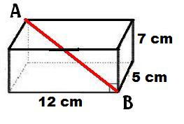

1. Ali and Evan are standing 100 m apart along a riverbank. Help Cole calculate the **height** of the cliff across the river.

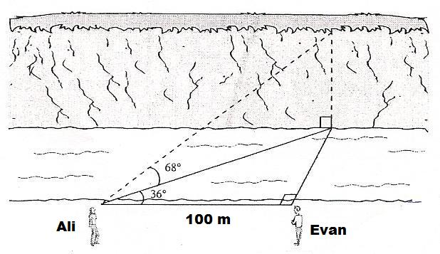

|  |
| --- |
| **Formula 🡪 Substitute 🡪 Steps to Solve 🡪 Answer (Units)** |

|  |
| --- |
| **The following questions are worth 2 points each** |

1. Help Ken determine the **slope** of side **AB**.

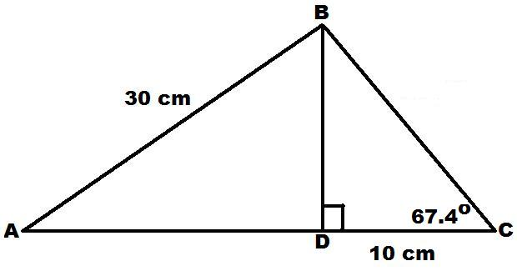

1. If the **angle of elevation** of the slant height is **70°** and the **radius** is **6 cm**, help Gillian calculate the **surface area** of the cone [SA = πr2 + πrs ].

