|  |
| --- |
| Measurement 10 Booklet |

Name:

|  |
| --- |
| referents1A.jpgruler1.jpg1966chevimpala.jpgaudiTT.jpg  scalediagram1.JPGmapscale3.jpg  amblyommatic.jpgscalediagram3.jpgspaceneedle.jpg |

|  |
| --- |
| **Measurement Booklet: Internet Research Information** |

|  |  |
| --- | --- |
| Your height (in feet and inches) |  |
| Your body mass (in pounds) |  |
| capacity of a soda / juice bottle (in mL) |  |
| today’s temperature (in °C) |  |
| elevation above sea level of Langley, BC |  |

|  |  |
| --- | --- |
| Your holiday destination |  |
| Distance (in miles) from Langley |  |

|  |  |
| --- | --- |
| Your vehicle to drive |  |
| Your vehicle’s fuel efficiency (in |  |

|  |  |
| --- | --- |
| price of gasoline at your destination  (in USD per US gallon) |  |
| today’s exchange rate (USD to CDN) |  |
| today’s price of gasoline in Langley |  |

|  |
| --- |
| **Quick Conversions** |

* Show your **intermediate steps** (including **conversion factors**) to receive full marks :

1. Convert your height (in feet and inches) into **centimeters**:
2. Convert your body mass (in pounds) into **kilograms** :
3. Convert a juice bottle (in mL) into **Canadian ounces** :
4. Convert today’s temperature (in °C) into **degrees Fahrenheit**) :
5. Convert Langley’s elevation above sea level into **feet** :

|  |
| --- |
| **Other Conversions** |

|  |
| --- |
| **Use the information below to help answer the following question** |

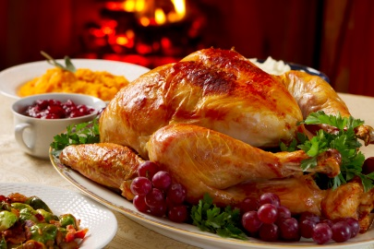Sally bought an **8.63 kg** turkey to cook for Christmas dinner.

It is recommended that she cook it for a minimum of **18 minutes per pound**.

1. For **how long** should she cook the turkey?

|  |
| --- |
| **Use the information below to help answer the following question** |

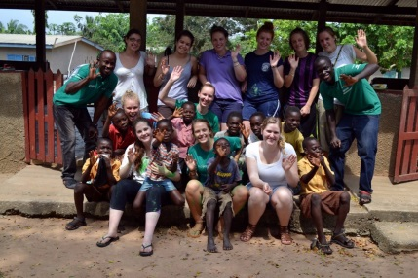Lesley and her nursing friends are planning a medical mission trip to Ghana.

They are told they will need to raise **$1400 CDN** in order to travel there for the month.

1 CDN : $0.760836 USD $1.31434 CDN : 1 USD

1 USD : 4.25997 Cedi $0.234743 USD : 1 Cedi

1. How many **Cedi** (the currency used in Ghana) will **$1400 CDN** purchase?

|  |
| --- |
| **Holiday Conversions** |

* Your holiday destination :
* Your vehicle :

1. Convert the distance to your destination (in miles) into **kilometres** :
2. Calculate the **number of litres** needed to drive to your destination:
3. Convert the USD per USG into a **CDN ¢ per litre** equivalent :
4. Calculate the **cost** (in CDN) of driving to your destination :
5. Calculate the **cost** (in CDN) of driving an **equivalent distance** in Canada using **Canadian** gas prices :

|  |
| --- |
| **Measurement** |

1. Measure the length of the fork – in **Imperial** units – and then **show your steps** to convert this into a **Metric** equivalent :

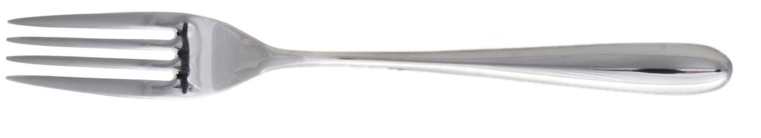

1. You are planning to walk to the Tim Hortons in Murrayville. Describe **how** you could **estimate** how far you walked.



|  |
| --- |
| **Measurement Combinations (2 pts. ea.)** |

|  |
| --- |
| **Formula 🡪 Substitute 🡪 Steps to Solve 🡪 Answer (units)** |

1. Determine the **volume** of the cylinder, shown below :

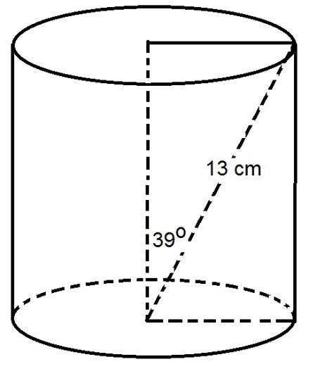

1. Calculate the **lateral surface area** of the cone, shown below :

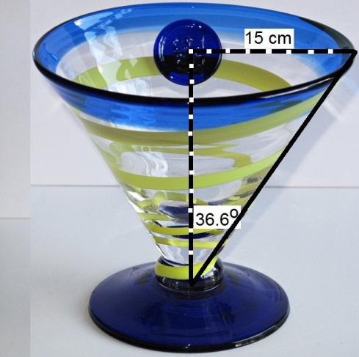

|  |
| --- |
| **Composite Prisms** |

|  |
| --- |
| **Formula 🡪 Substitute 🡪 Steps to Solve 🡪 Answer (units)** |

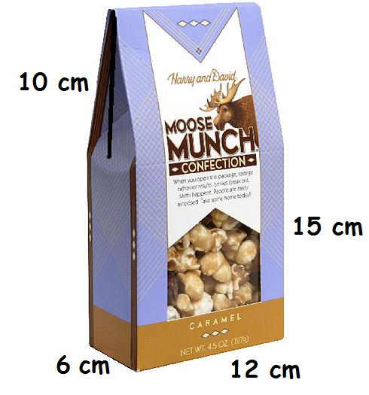

1. Calculate the **volume** of the container : (2 points)